**PROGRESSIVE WEB APP (PWA)**

PWA (Progressive Web Apps) is one of the most talked about technology shifts in the web and has gained unparalleled momentum among the practitioners in the IT world. If you are building for the web, I’m sure that PWA is the latest ‘buzzword’ that has been added to your work vocabulary. It’s not surprising because PWA has made the far fetched dream of installing web apps on phone for real.

**WHAT IS A PROGRESSIVE WEB APP ?**

Progressive Web Apps (PWA) combine new technologies with established best practices for creating reliable, accessible, and engaging experiences. They give users a native-like experience with a user friendly opt-in installation flow.

**A Progressive Web App** (PWA) is a web app that uses modern web capabilities to deliver an app-like experience to users. It is the next big thing in web development as they bring **mobile-app-like experiences** to your users without requiring them to install an app from the app store/ play store.

These apps meet certain requirements , are deployed to servers, accessible through URLs, and indexed by search engines.

**WHAT IS REQUIRED ?**

To be considered a Progressive Web App, the app must be:

* **Progressive** - Work for every user, regardless of browser choice, because they are built with progressive enhancement as a core tenet.
* **Responsive** - Fit any form factor, desktop, mobile, tablet, or whatever is next.
* **Connectivity independent** - Enhanced with service workers to work offline or on low quality networks.
* **App-like** - Use the app-shell model to provide app-style navigation and interactions.
* **Fresh** - Always up-to-date thanks to the service worker update process.
* **Safe** - Served via HTTPS to prevent snooping and ensure content has not been tampered with.
* **Discoverable** - Are identifiable as “applications” thanks to W3C manifests and service worker registration scope allowing search engines to find them.
* **Re-engageable** - Make re-engagement easy through features like push notifications.
* **Installable** - Allow users to “keep” apps they find most useful on their home screen without the hassle of an app store.
* **Linkable -** Easily share via URL and not require complex installation.

**OTHER REQUIREMENTS :**

**Offline Support -** Apps should be able to work offline. Whether that be displaying a proper “offline” message or caching app data for display purpose.

**Web App Manifest-** An app manifest file should describe the resources your app will need. This includes your app’s displayed name, icons, as well as splash screen. If you link to the manifest file in your index.html, browsers will detect that and load the resources for you.

#### **Service Worker-** Service worker could be mentioned in Offline Support, but it really deserves its own section. Service worker provides a programmatic way to cache app resources. Be it JavaScript files or JSON data from a HTTP request. The programmatic API allows developers to decide how to handle caching and provides a much more flexible experience than other options.

**WHY BUILD A PROGRESSIVE WEB APP (PWA) ?**

The cost of developing, testing, and maintaining applications for several platforms is unreasonable for those companies who build apps for their internal use. Thus, they believe that PWA will become a more viable alternative to them. Even though progressive apps are build on the new technologies, they are already widely used in the industries. Some companies that uses PWA’s are :



If ever the best of web and the best of apps had a clone child — it is PWA. Or else, it’s just that the web page that can behave more like an app downloaded from the App Store/ Play Store. It starts as a normal web page in a browser, and as a user explores the webpage, they get the prompt if they would like to “Add to Home Screen”. Once the user gives the thumbs up to this prompt, then PWA gets added to their home screen. Once open from the home screen, it can even hide the browser UI controls and appear as an app.

PWA has managed to bridge the gap in the web. The web has always been thirsty for reliable performance at par with the native apps. It has always yearned for a place in the notification tray and in the home screen just like an app. More than 40% of the users bounce from the websites that take more than 3 seconds to load. PWA is a solution for this faced by the users. It is all about removing friction and making it easy for the users to get to what they want.

The entire credit for this seamless experience should be given to the **Service Worker**( A script that the browser runs in the background separate from web page), which is the backbone of every PWA. They enable content caching, background content updating, push notification and offline function to prior visited sites (that means, after the first visit to a website, the site and app will be reliably fast even on flaky networks).

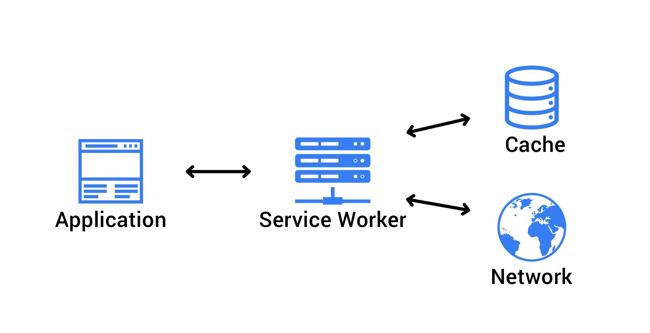

Fast first load reliable performance happens when **Accelerated Mobile Apps (**AMP) meets the Service Worker. AMP makes the web fast for users and simple for developers. It provides reliable fast web components for first load. These components are much faster to load and less data hungry. The websites which uses the combo of AMP and service worker will provide a reliable speed has of native apps.Once the page is loaded the site setups the service worker and assets are cached intelligently. This will always keep the PWA up to date thereby freeing the users from the frequent updates to be done from the App Store.

**THE THREE COMPONENTS OF PWA :**

The progressive web app basically comprises three elements, which is also the core of its functionality. It includes:

• A service worker

• An app shell

• An app manifest

**A Service Worker**

The Service Worker can rightly be said as the backbone of the progressive web apps. It is the major technology that fuels the progressive apps and is known for its robustness and power. The progressive apps are able to offer offline navigation and content caching, push notifications and updating content facility due to the presence of the service worker. This technology also helps in bringing connectivity changes and operates backstage to run in response to a network.

**App Shell**

The App Shell is another important component of the progressive web apps and is a design concept, which initially allows the loading of the app shell before the content. It caches the design and the content on separate notes and helps in improving the performance of the app.

**App Manifest**

The App Manifest is a wonderful tool that allows the installation of the app from the browser and then pins it into the device’s home screen, similar to what we do on your personal computers and laptops. You can create a shortcut for any web app and install it on the home screen with this support. In order to specify the fact that the web app can be installed as an app, the developers write a manifest.json file and it is connected to the main HTML page.

**THE BENEFITS OF PROGRESSIVE WEB APPS :**

Once we have discussed the definition and the major components of the progressive web apps, let’s now focus on what are the key benefits of PWA.

**PWA supports the Offline Mode as Well**

One of the main advantages of Progressive Web Apps is that it supports the browsing even if there is no or very limited internet connection. This is something which you will not find in the case of websites.

Thus, it ensures more and more user engagement and also allows you to save the information automatically. The offline page contains a logo, some info, and few advanced features. For instance, people can view the product list displayed on the e-commerce app.

**Makes Use of Low Data**

The PWAs also make use of low internet data as compared to the native apps. It has been seen that you can save a lot of monthly data, thus reducing your bill on internet connection.

**Push Notifications**

They are a great asset tool for mobile marketing today helping to bring more target customers on the board. And the progressive web apps are blessed to have this vital weapon where you can send specific messages in bulk related to discount offers, rewards, and coupons. This helps in boosting the sales to higher up the order.

**Downloads are awesomely Fast**

Unlike the native apps, the users don’t have to go to the Play Store to download the progressive web apps. And they also do not take much time to get downloaded. They can be directly downloaded onto the device. It has its own icons on the device.

**No Need for App Submission**

The developers will feel relieved to hear the fact that with progressive web apps they don’t need to submit the app into the Google Play Store or [App Store](https://www.techgenyz.com/2018/08/31/privacy-policy-for-apps-in-app-store/). This reduces their workload and also tends to save a lot of time and money.

Plus, they also do not need any approval or consent to update the app and can push for it at regular intervals. The updates are automatically downloaded when the app is relaunched.

**Best Option if Budget is less**

The Progressive Web Apps can be a viable option for any business enterprise or a startup, which is having a tight or low budget estimate. The cost of developing PWA is much lower than the native apps.

As such the cost estimate of developing a native app would be around $25k-$80k, whereas the PWA costs around a fraction of that i.e. $6k to $10k. Moreover, it also offers good overall results for the business with the best ROI.

**Shows Positive SEO Results**

Since the PWA has great loading speed, it tends to boost the accessibility and searching power of the app. It offers a great overall user experience, adding to the success story of your business. It is a positive indication for marketing strategy.

**Some other Benefits**

* The progressive web apps just act like websites providing the same features and functionalities including accessing the database.
* They are known to deliver improved performance.

## **The Progressive Web App Features**

1. Generally speaking, the essential features of the progressive web apps have already been discussed above when we are outlining its benefits. And more so, the features also remain the same such as no app submission, push notifications, faster loading time, and SEO benefits, reduce the cost of development and so on.

2. In addition to these, the PWAs are known for their responsiveness as they can fit into any shape such as desktop, mobile, tablet.

3. They can work with any browser the user chooses due to the fact that they are created with progressive enhancement as a core tenet.

4. You don’t have to think much from the security point of view. They are highly secured with the HTTPS.

**The Popular Clientele**

It can boast of having some of the most prestigious clientele including Alibaba, Flipkart, Twitter, Ola, Pinterest, OLX, Bookmyshow and much more.

## **HOW TO CREATE A PROGRESSIVE WEB APP :**

## 1. In the first instance, you have to do the test and check if your site is working as PWA. For this you can use a chrome extension; for instance, the Lighthouse. After the installation, you have to click on the Lighthouse icon in the top right of the browser to get an access to the report.

2. In the second step, you are required to create an icon for the site that will be on the home screen.

3. Next is the registration with the service worker.

4. The service worker

5. Next is building a sw.js and adding index.html cache

6. You also have to develop a manifest file, which would be supporting add home screen feature.

## **CONCLUSION :**

The Progressive Web Apps is getting a good positive response from the web and mobile app development Industry. Despite its drawbacks, it is not getting support from Apple iOS, it has a number of advantages and features that can take any business to a result-oriented position. They also make the job of the app developers much more easily reducing the overall cost and time of development.